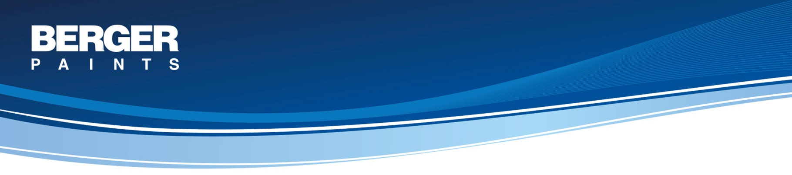
SYSTEM : FAST DRYING AND DURABLE ENAMEL FINISH FOR INTERIORS / EXTERIORS
Surface – GI

System Description

Primary Coat: 1 coat of Berger Redoxide primer
A general purpose Metal Primer based on synthetic resin pigmented with Red Oxide and other rust inhibitive pigments that provides short term protection for steel during and immediately after fabrication. It can be applied to non-blast cleaned surfaces.

Volume Solids: 50% ± 2%

Top Coat: 2 coats of Select All in one Enamel
An enamel based on suitably modified alkyd containing titanium dioxide and other colorfast pigments to provide a tough, durable and hardwearing high gloss finish with good flow, hiding power and film build-up.

Volume Solids: 44% ± 2%

Recommended Areas of Application
Area of Use: Interior & Exterior
Substrate: Metal, Timber & Masonry surfaces

