Indoor Multisport Scoreboard BT6730 Video 12M 12P H15
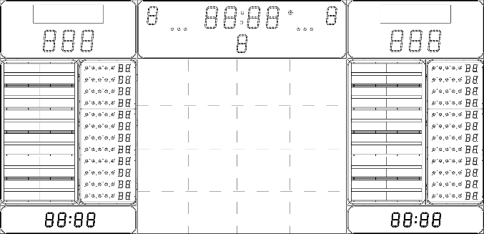
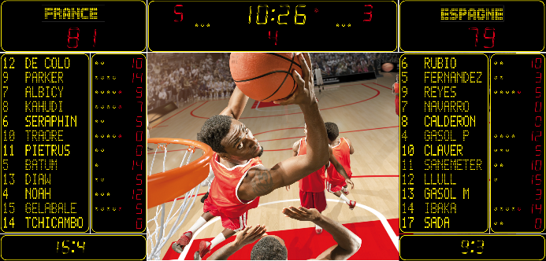

The indoor multisport digital scoreboard shall suitable for basketball FIBA level 1, international level volleyball and national level handball.

The scoreboard shall display the game clock, the teams’ names, each team score, the period number, the number of teams’ fouls, the number of time-out taken, the penalty timers, the names and numbers of up to 12 players, the number of points scored by each player, the game clock stopped indicator and shall feature an integrated horn and a LED video screen.

The scoreboard shall be able to manage, as a minimum, the following sports: basketball, handball, volleyball, tennis, table tennis, rink hockey, badminton, netball, futsal, floor ball and basic indoor sports.

- LED technology
- High luminosity LED technology shall be used to ensure proper readability in all indoor light conditions and provide a viewing angle of 160°.

- The luminosity level of the LED display shall be adjustable from the controlling keyboard at any time during the game.

- Game clock and scores
- The game clock and the scores shall be displayed with 30cm digits and shall be readable from as far as 150m.

- A four-digit game clock shall display minutes and seconds with yellow LEDs, be capable of counting up or down and, when the game is not in progress, be able to display the local time and optionally the temperature.

- The teams’ score shall use a three digits red LEDS display capable of displaying scores from 0 to 999.

- Teams’ names

- The teams’ names shall be digitally displayed on the same alphanumerical line with 20cm high yellow characters.

- 10 characters or less shall be used for each team’s name.

- The names shall be programmable from the control keyboard or from a personal computer.

- Period number and number of teams’ fouls

- The period number shall be display by one red digit 25cm high located in the centre of the scoreboard for easy identification. This digit shall also be used to indicate the current set number.

- Each team’s fouls number shall be displayed by one 25cm red digits located on each side of the game clock. It also shall be used to indicate the number of won sets.

- Time-out indicators and game clock stopped indicator

- Three yellow dots shall be use for each team to display the time-outs taken and shall be located below each team’s name.

- One red dot indicator located near the game clock shall light up every time the game clock is stopped.
- Horn

- A 120dB horn shall be integrated to the scoreboard and shall be sounded for 5 seconds at the end of a period, for 3 seconds when the game clock is stopped manually or at the end of the possession time.

- It shall possible to stop the horn from the keyboard.

- Multipurpose timers

- There shall be 1 line of multipurpose timers per team.

- Each line shall consist of two 20cm yellow digits for the player’s number and three 20cm yellow digits for the timer.

- The information displayed by each line shall be specific to the selected game.

- Players’ names and players’ numbers

- The players’ names and numbers shall be digitally displayed with 15cm high yellow characters.

- Each player’s name shall be made of 12 characters or less.

- Each player’s number shall be made of 2 characters

- The names and numbers shall be programmable from the control keyboard or from a personal computer.

- Individual fouls and points per player (Basketball only)

- 12 lines shall be used to indicate the personal fouls assigned to each player.

- Each line shall consist of four yellow dots and one red dot

- The number of points scored by each player shall be displayed by two 15cm red digits on each of the 12 lines.

- LED video screen

- A 12m² LED video screen shall be integrated in the scoreboard.

- The LED video screen shall have a pitch of 10 mm (preferred 8 mm)

- The LED video screen shall be used to display game events, sponsors’ advertisement and partners’ messages.

- Technical characteristics

- The scoreboard shall have a shockproof steel casing rated no less than IK09 in order to withstand impact from basketballs, handballs...

- Access to all electronic components shall be done from the front of the scoreboard for easy maintenance.

- The scoreboard shall measure approximately 8388mm x 4015mm x 80mm. and have a power consumption of no more than 3830W.

- The 7m² LED video screen shall measure 3840 x 3200 x 107 and have a consumption of no more than 7200W.

- The Scoreboard and video screen assembly shall weigh no more than 1350Kg.

- The scoreboard shall be power by the 230V, 50/60Hz mains and protected by an 18A-D curve circuit breaker.

- The scoreboard shall be power by the 230V, 50/60Hz mains and protected by a 33A-D curve circuit breaker.

- At least two multisport digital keyboards shall be used to control the scoreboard via cable.

- The software VideoSport install on the computer shall be used to control the video screen.

The power capability of the 230V power source provided by the installer shall be no less than 15kW.

Required accessories

- Multisport digital main keyboard
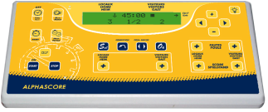

- Technical characteristics

- The communication between the keyboard and the scoreboard shall be accomplished through either cable.

- The keyboard shall have a 2-line, 20 characters/line LCD display.

- A 100-240V/15V power adapter shall be supplied to power the keyboard.

- A backup battery shall be integrated to the keyboard to provide approximately 8 hours of autonomy.

- Main keyboard functions

The main keyboard shall be able to perform the following operations:

- Sport selection and configuration,
- Enter the Team’s names
- Start a new match
- Reset the game clock
- Start and stop the game clock
- Increment and decrement the Home and Guest scores
- Selection of the game clock counting mode: up or down
- Selection of game clock display or local time display
- Adjustment of the scoreboards luminosity
- Time setting
- Assignment of time-outs Home/Guest
- Assignment of team fouls
- Control of penalty timers
- Control of the horn.

- Multisport digital secondary keyboard
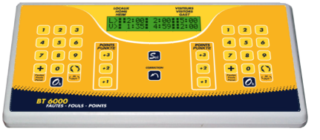

- Technical characteristics

- The communication with the scoreboard shall take place through the main keyboard

- The secondary keyboard shall have a 2-line, 20 characters/line LCD display.

- Power to the secondary keyboard shall be supplied by the main keyboard.

- Secondary keyboard functions

The secondary keyboard shall be able to perform the following operations:

- Assignment of personal fouls or penalties to individual players of each team
- Enter the player number or the time-out and penalty duration for each team
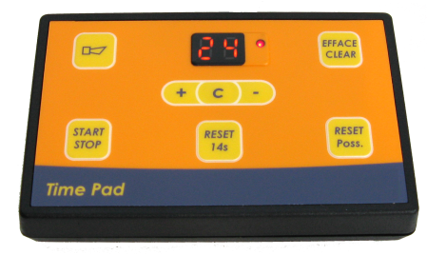
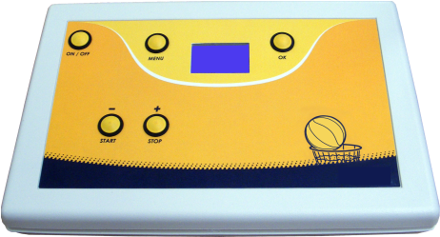
- Award 1, 2 or 3 points score to a team or to a player

