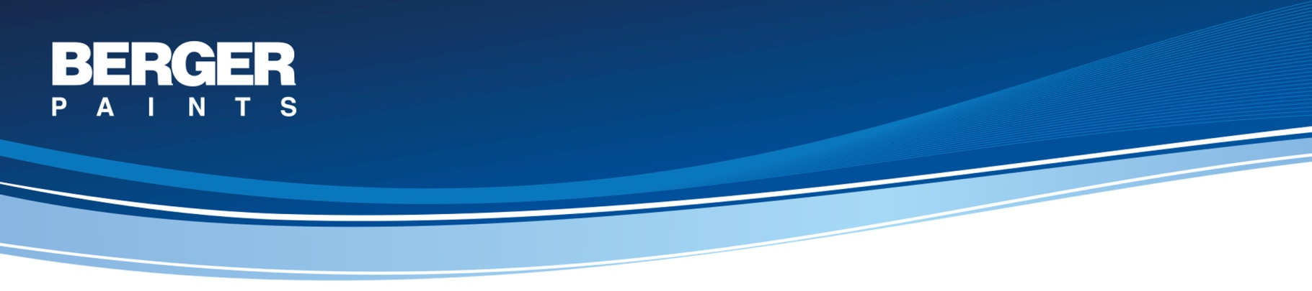
SYSTEM : DESIGNER TEXTURE FINISH FOR EXTERIORS
Concrete and Masonry Surface – Exterior

System Description

Primary Coat: 1 coat Weathercoat AR Primer
A premium quality acrylic co-polymer based primer with good alkali resisting properties designed to provide a sound base for texture coating from the Berger range.

Volume Solids: 40% ± 2%

Top Coat: 2 Coats of Select Tartaruga Roughcast
Tartaruga Roughcast is a synthetic render-cum-finish which can be applied straight to most fairface surface such as concrete, plaster, brick work both exterior and interior. Tartaruga Roughcast is ready mixed coating composed of high quality exterior durable polymer reason, and weather resistant pigments, incorporating special graded marble granules. With its unique engraved finish, Tartaruga Roughcast is truly a decorative plaster and superb finish both in one. Tartaruga Roughcast most effectively combines the decorative appeal of a unique finish with the anti arbonation performance of the coating. Tartaruga Roughcast incorporates specially selected fungicides and algaecides which reduce efflorescence, resist alkaline hydrolysis, tropical fugas, algae and mould growth, both on the surface and beneath. Tartaruga Roughcast has excellent ultra violet resistance, adhesion on various surface and color retention. Tartaruga Roughcast has a breathable film that breathes out trapped moisture both from the paint surface as well as the substrate

Volume Solids: 75% ± 2%

Recommended Areas of Application
Area of Use: Exterior & Interior
Substrate: Concrete, Plaster, Masonry, Brickwork, Block work, Timber.

