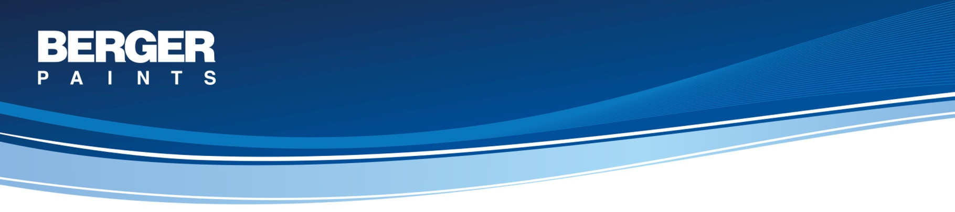
SYSTEM : DURABLE HEAVY TEXTURE - WOMC FOR EXTERIORS
Concrete and Masonry Surface – Exterior

System Description

Primary Coat: 1 coat Weathercoat AR Primer
A premium quality acrylic co-polymer based primer with good alkali resisting properties designed to provide a sound base for texture coating from the Berger range.

Volume Solids: 40% ± 2%

Top Coat: 2 coats of Select Heavy Texture (WOMC)
A heavy texture coating based on a tough, flexible acrylate co-polymer resin, pigmented with titanium dioxide and other light fast pigments reinforced with selected quartz aggregates and mica. Its formulation incorporating fungicides and algaecides, and its heavy build ensures good weather resistance, and also helps cover surface cracks and irregularities.

Volume Solids: 68% ± 2%

Recommended Areas of Application
Area of Use: Exterior & Interior
Substrate: Concrete, Plaster, Masonry, Brickwork, Block work, Gypsum, Timber.

